OG Hair Salon

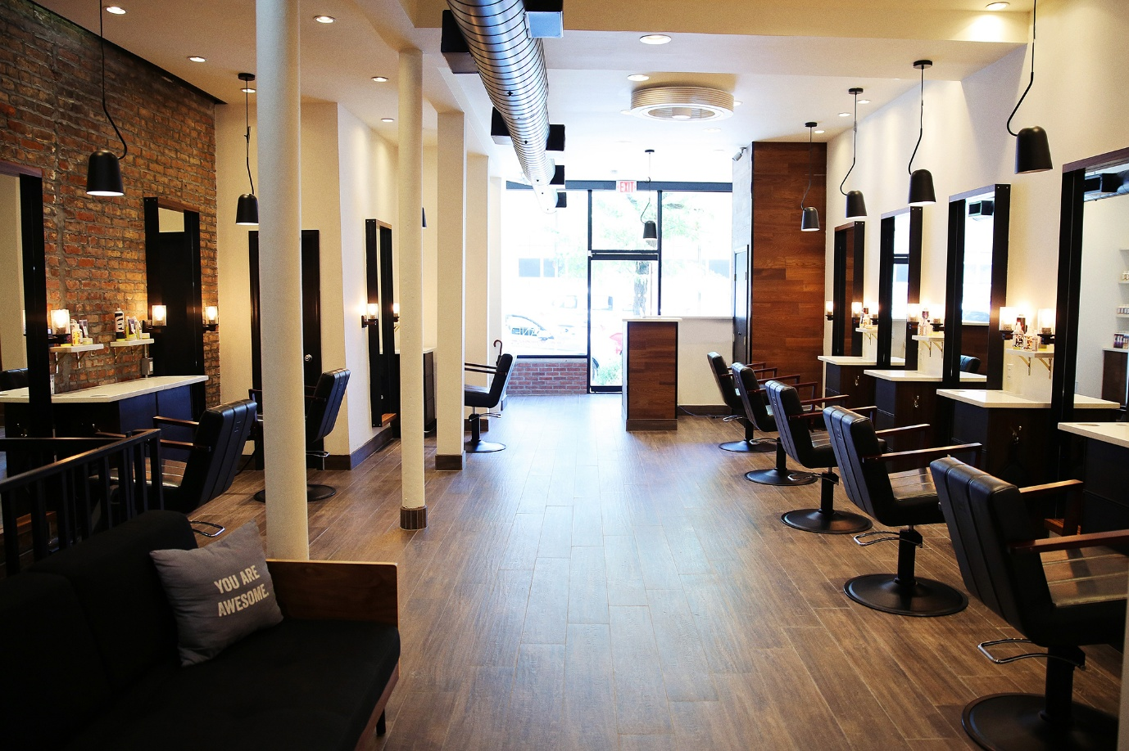

Web Development ( Introduction )
WEDE5020
Ongezwa Unakho Hlengiwe
ST10524345

Contents

No table of contents entries found.

Organisation Overview
This proposal is about a hairsalon that started from 2009. The hair salon came about when I would be playing with my friends hair and that’s where the love of dealing with came up. The name of the salon is OG Hair Salon which originates from my name, Ongezwa. Our mission is to offer high quality services and treatment to our customers with an excellent environment for our customers. Our vision is to become the best and memorable hair, making our customers feel comfortable every time they come and always feel the need to come back. Our target market is young adults who want fashionable hairstyles while receiving excellent services.

Website Goals and Objectives
Our goal by creating this website is to raise awareness about our brand, this website will showcase the brand to customers who might be interested in our services. It is to also be convenient to our customers by enabling online appointments and orders, this will help our customers to buy our products without coming to our establishment. Our objectives are to increase our salon sales through online promotions and improve customer convenience by making them book and by from their own comfort, from anywhere. The key performance indicators we will you to measure the success of the website is customer feedback and reviews, this will also let us know where we need to improve in order for our business to be a success. Sales growth will also be our indicator, if we make more sales after the launch of the website that will be indicating that the website is attracting customers and that helps with sales.

Proposed Website Features and Functionality
- Home Page
This will introduce the salons highlights, excellent services and an overview of our establishment and the hairstyles that have been done in the salon.

- Services and Pricing Page
This is to help the customers to know which and which not services we offer, it is to also help with the customers budget so they know how much they will have to spend.

- Location Page
To help the customers to get to the salon without any struggles

- Contact Page
To help customers with communicating with the salon and to ask any questions they might have.

Design and User Experience
The website will have a clean and modern look which is a reflection of the experience customers will get from our salon using beige as our main colour. The website will have Montserrat for the headings and sub heading and Arial for our body texts. The layout and design will be simple and straightforward, this is to make it easy for the customers to navigate.

Budget
The budget for our website includes Domain Name, Web Hosting, Website Development, Online Booking System and Website Maintenance. This all sums up to approximately R8000 to R9600.

References

